Exposure Visit of Scientists, Students, Farmers at ICFRE-IFP, Ranchi & its sub centres
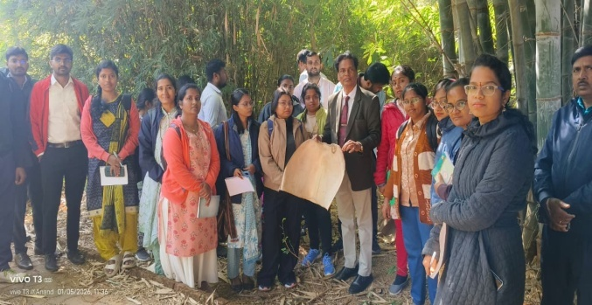 | 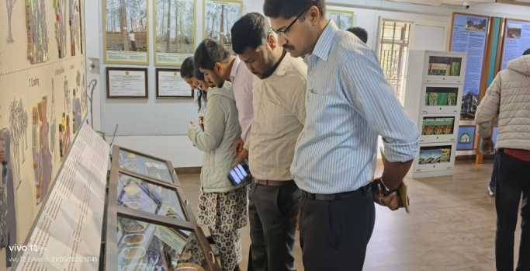
Visit of Newly appointed Scientists of CSB-CTRTI, Ranchi & ICAR-RCER-RS, Ranchi
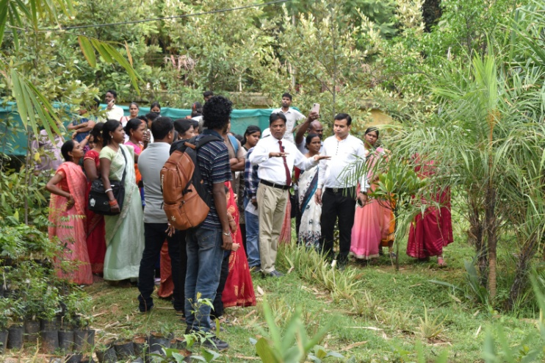 | 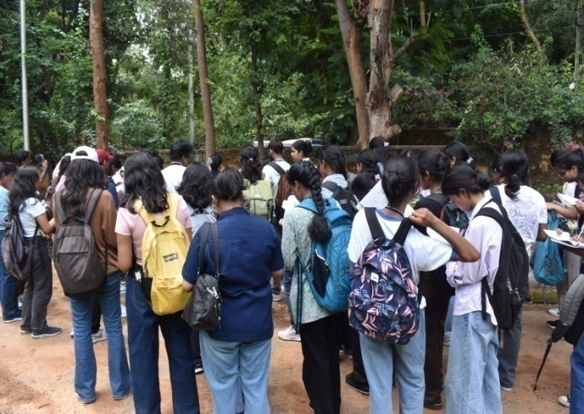
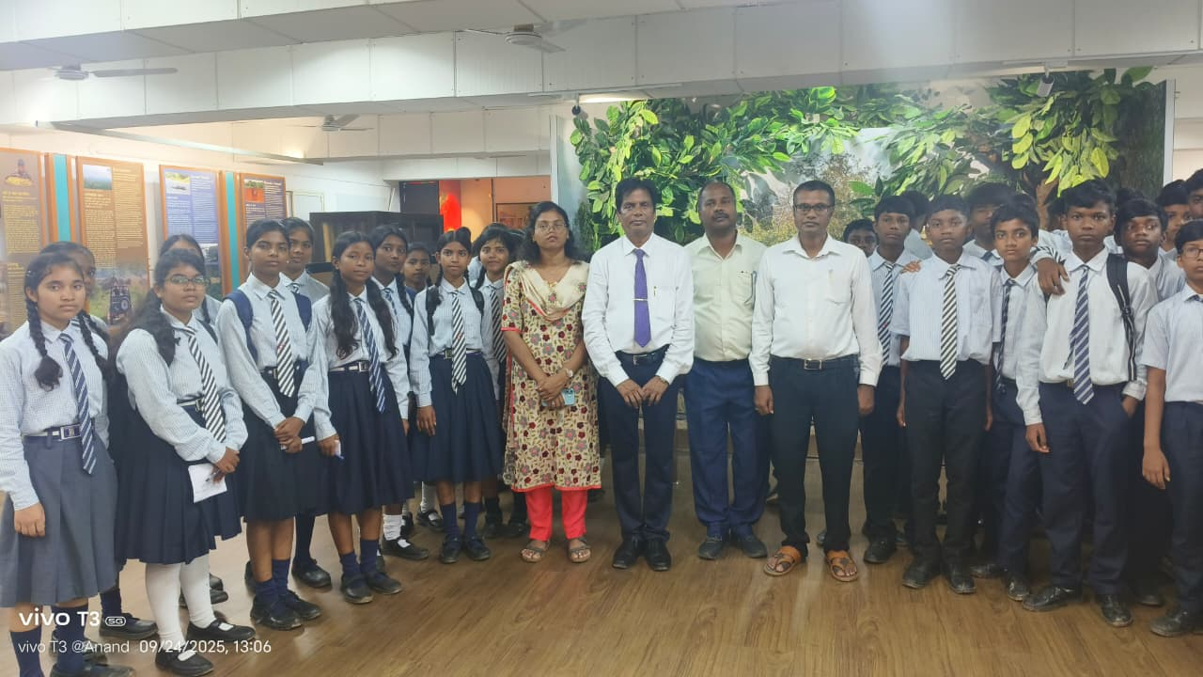 | 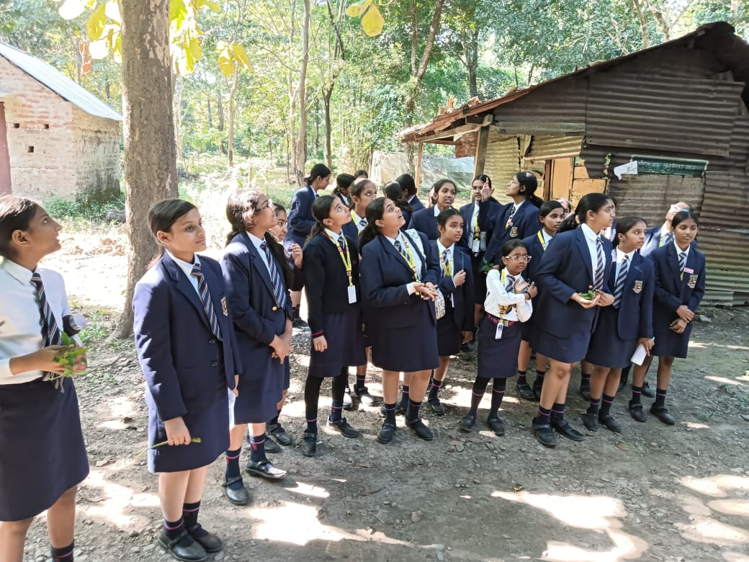
Visit of Students of various colleges &Schools at ICFRE-IFP, Ranchi & its sub centers

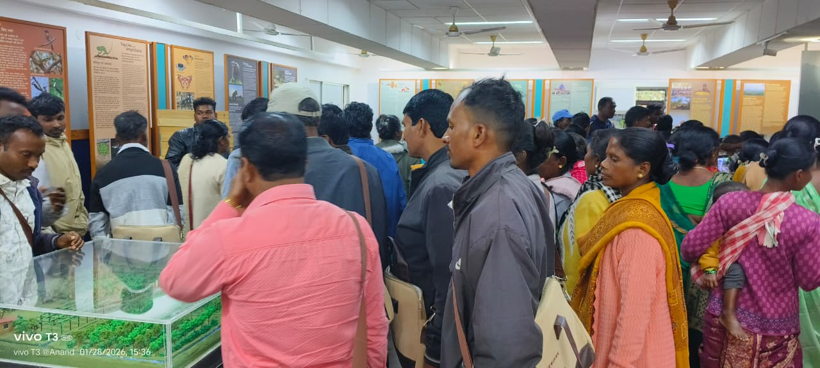 |  | 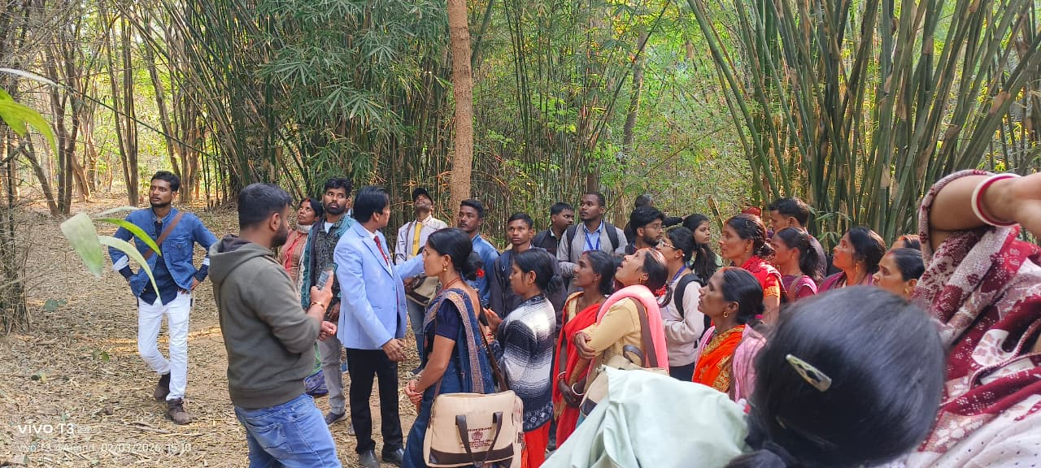
Exposure visit of farmers of different villages of Jharkhand

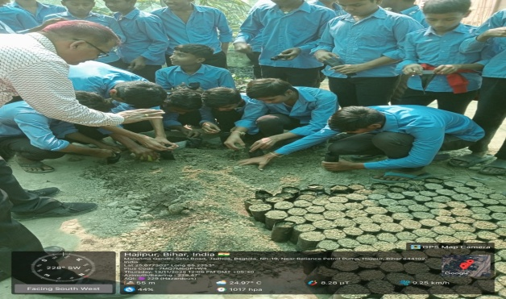 |  | 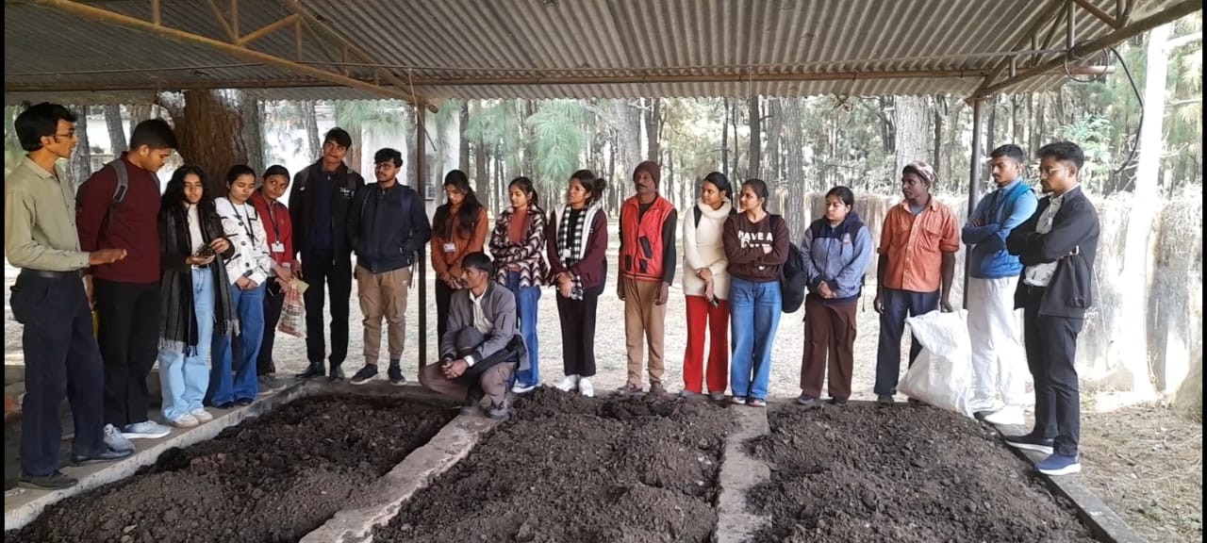
Visit of students at Jadua & Mandar sub centre of ICFRE-IFP, Ranchi under Prakriti program

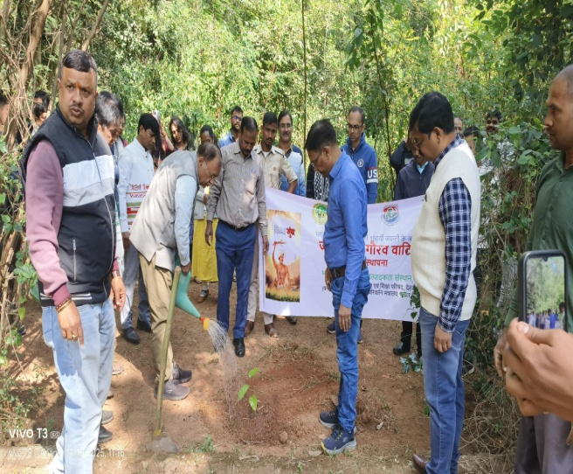 | 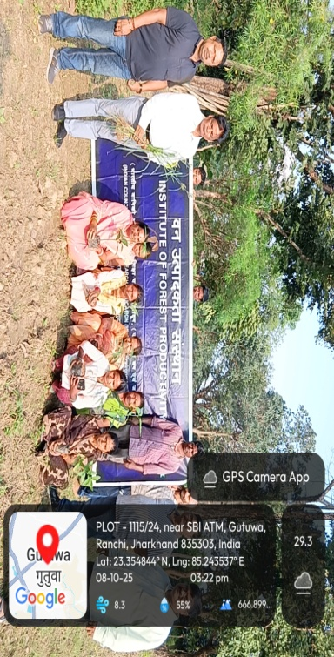
Different programs organized by ICFRE-IFP, Ranchi

Students-Scientist Interaction under Prakriti Program
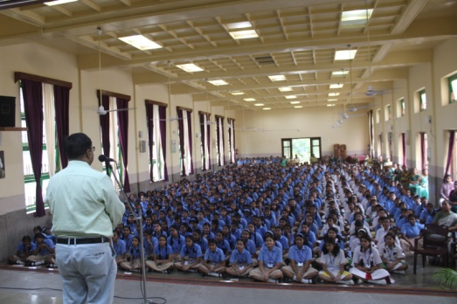 | 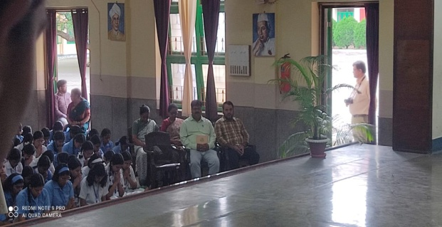
At Loretto Academy, Ranchi

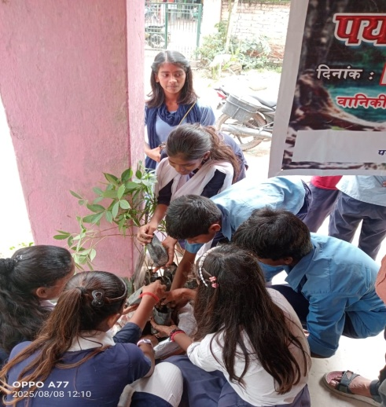 | 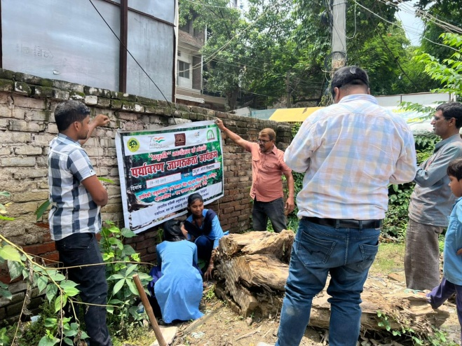
At Jadua Middle School, Hajipur

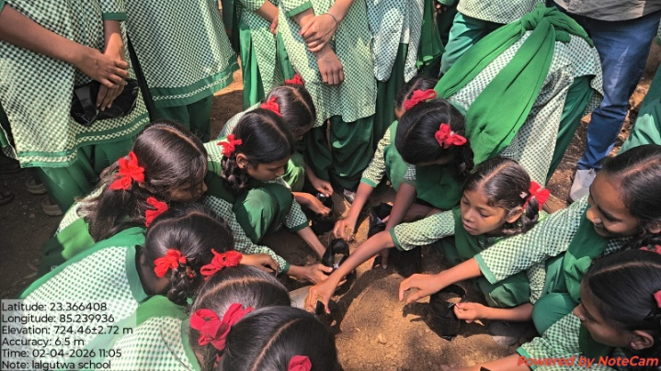 | 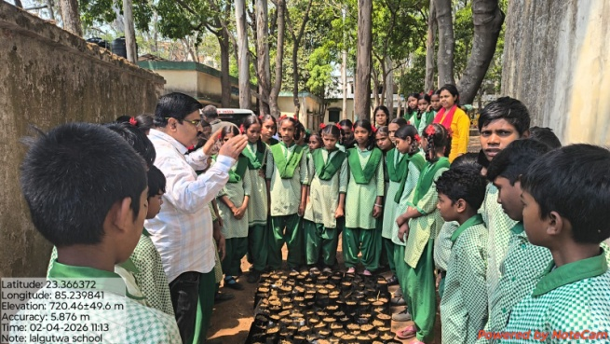
At Lalgutuwa Middle School, Ranchi

TREE GROWERS MELA
Organized under the supervision of the ICFRE- Institute of Forest Productivity , Ranchi.
- Sessions on climate resilience and soil conservation
- Participation of farmers, women SHGs, forest officials etc
- Focus on medicinal & aromatic plants alongside timber and multi-use species. Demonstrations emphasize nursery management, organic pest control and biodiversityfriendly practices.
- Promotion of fruit-bearing &native fast-growing species
- Youth and women engagement for income-generating activities
- Demonstration of value added products (bamboo crafts, pickles, lac products etc)

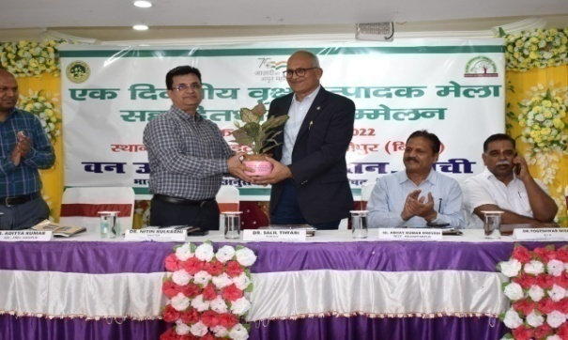 |  | 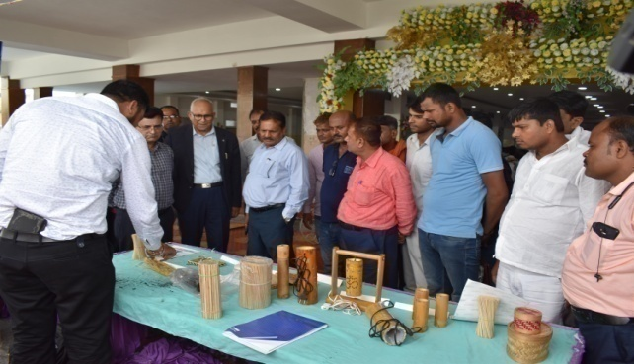
Tree Growers Mela cum stakeholder meet at Hajipur, Bihar on 21st September 2022

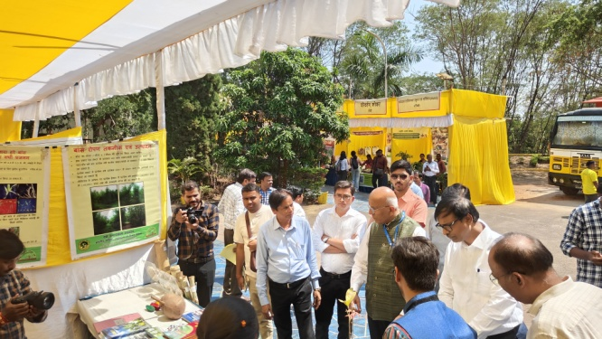 |  | 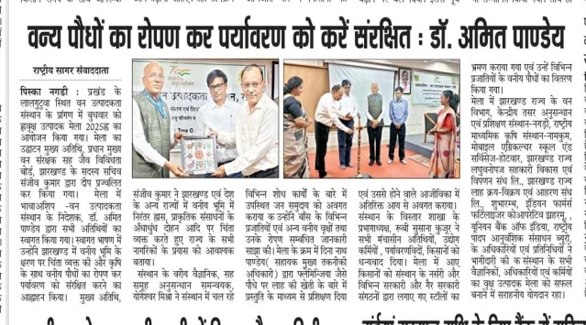
Tree Growers Mela at ICFRE-IFP, Ranchi on 19th March 2025

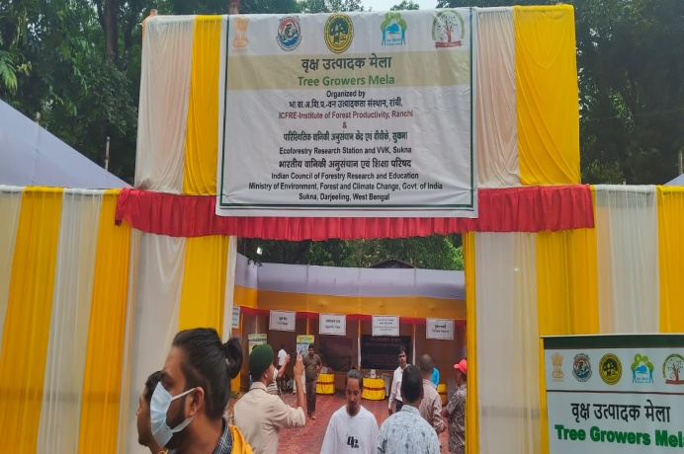 |  | 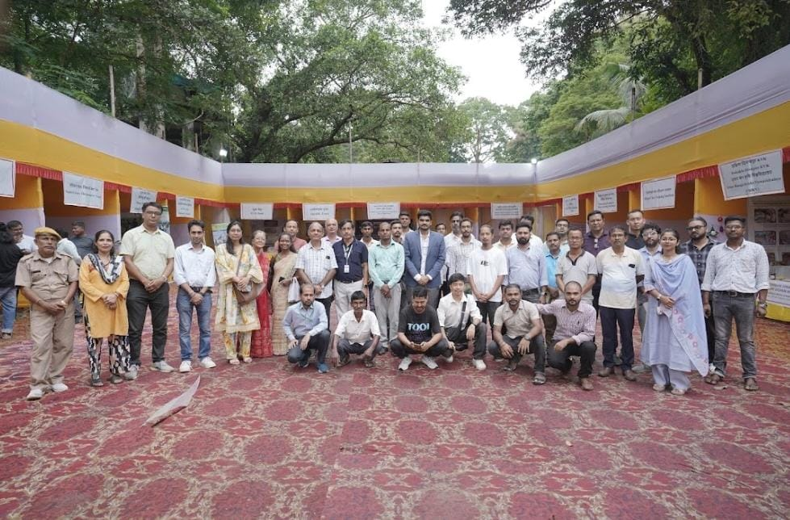
Tree Growers Mela at Sukna, Siliguri, West Begal on 10thSeptember 2025

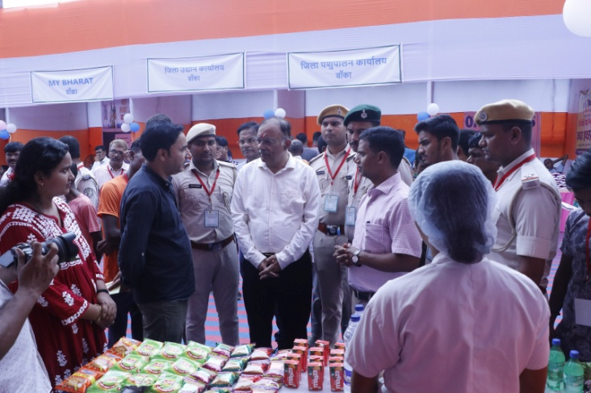 |  | 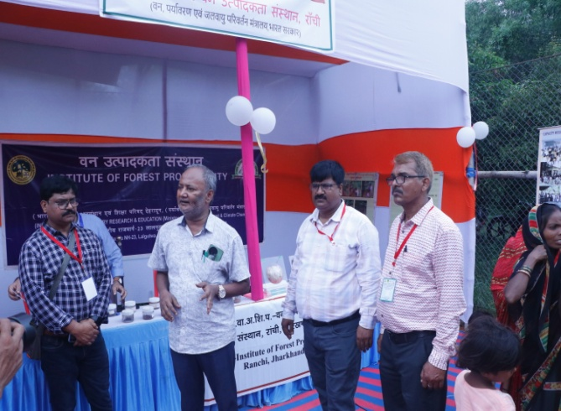
Tree Growers Mela at Supaha, Banka, Bihar on 18th September 2025

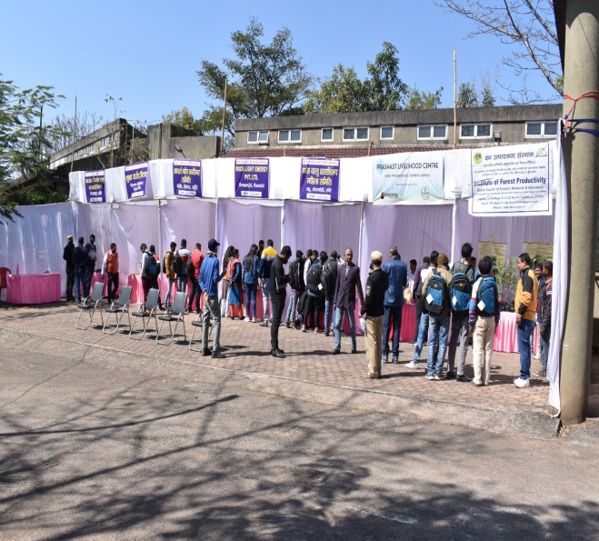 | 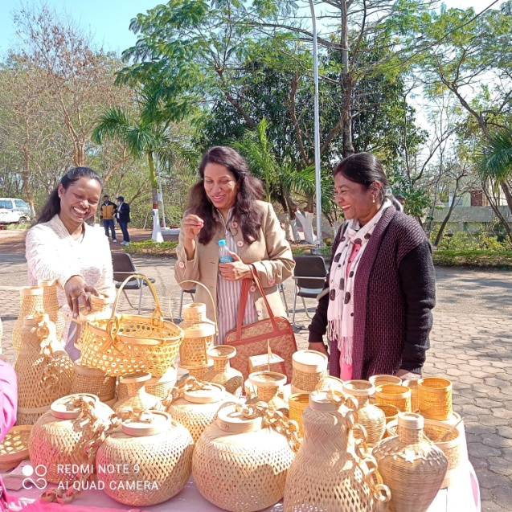
Bamboo Producer cum stakeholder meet under Tree Growers Mela at ICFRE-IFP, Ranchi on 14th February 2022

Van Vigyan Kendra
A network of field centres delivering forestry training and quality planting materials to support sustainable livelihoods and ecological restoration across Jharkhand, Bihar and West Bengal.
Established by ICFRE under CAMPA (MoEF&CC), VVKs aim to bridge the gap between forestry research and field implementation. They translate scientific research into practical, fieldready technologies for afforestation, nursery management and livelihood enhancement.These centers also focus on capacity building, demonstration of improved practices, and promoting sustainable forest-based income opportunities for rural communities.
The major stakeholders include farmers, tribal communities, forest departments, research institutes, and rural youth entrepreneurs. These groups actively participate in training, demonstrations, and implementation of forestry-based livelihood activities.Their collaboration ensures better knowledge transfer, community participation, and long-term sustainability of forest and agroforestry initiatives.
Name of VVK | District & State | Date of Establishment | Location | GPS Coordinates | Facilities Available in VVK
VVK Jadua, Bihar | Hajipur, Patna, Bihar | 20.06.2019 | Hajipur, Patna, Bihar | 25° 40' 37.7796" N  85° 14' 9.5706" E | - 2 story building withone conference hall with seating capacity of approx 50pax  - One Mist chamber & one Hardening chamber with 4 units each.  - Open Nursery Beds.
VVK Sukna, Darjeeling, West Bengal | Darjeeling, West Bengal | 26.12.2021 | Sukna, Darjeeling, West Bengal | 26°47´49.0164” N  88°21´40.3842” E | - One conference hall at VVK, Sukna with seating capacity of approx 50 pax  - Projector, Projector Screen, Computer, UPS, Printer, Inverter, Signboard, Office Tables, Plastic Chairs.  - Water motor pump.  - Solar street lights and Solar battery.
VVK, Supaha, Banka (Bihar) | Banka, Bihar | 11.04.2022 | Near Samukhiya More, Amarpur Road, Banka | 24°56'17.7576"N &  86°54'5.3172"E | - 2 story building with one conference hall with seating capacity of approx 100 pax  - One Mist chamber & one Hardening chamber.  - Open Nursery Beds.

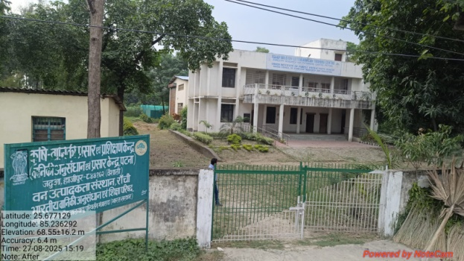 | 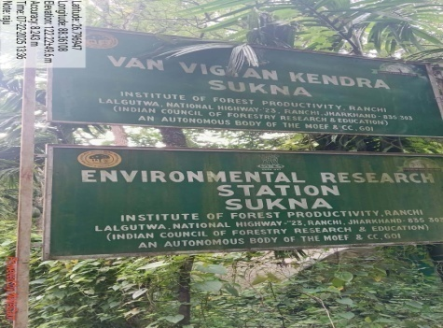 | 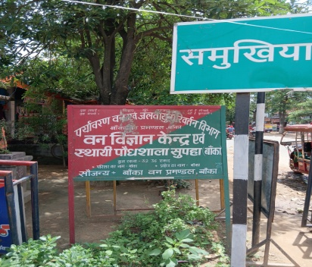
VVK, Jadua, Hajipur, Bihar | VVK, Sukna, Siliguri, W.Bengal | VVK, Supaha, Banka, Bihar

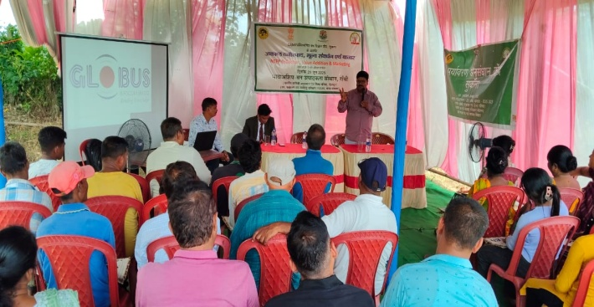 | 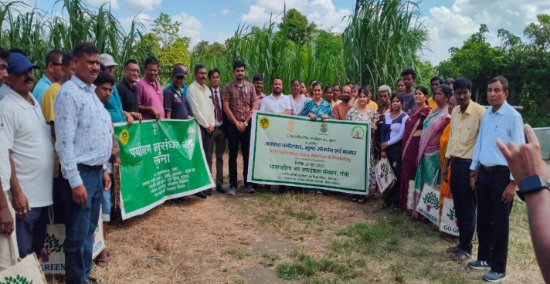
Training program under VVK, Sukna, Siliguri, West Bengal

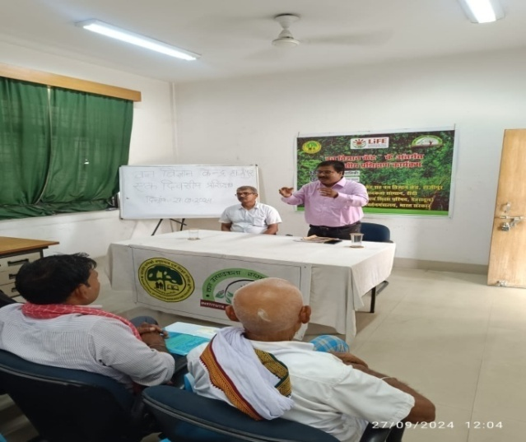 | 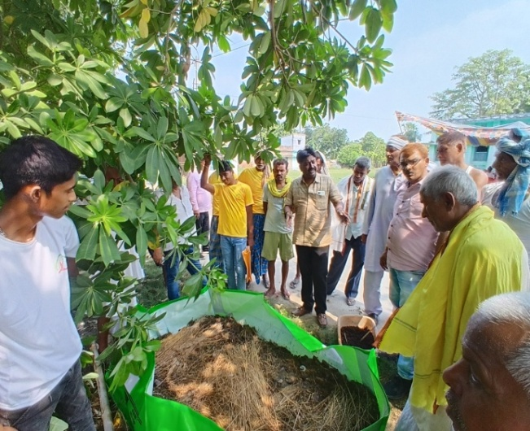
Training program under VVK, Jadua, Hajipur, Bihar

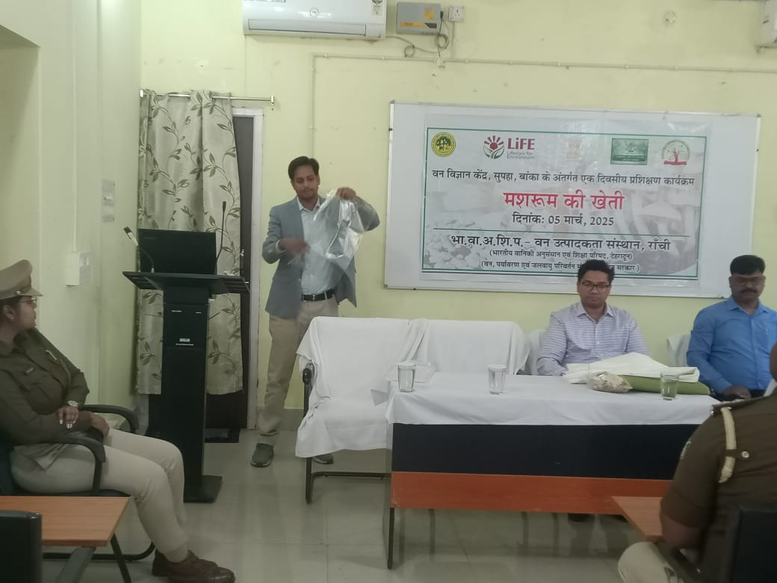 | 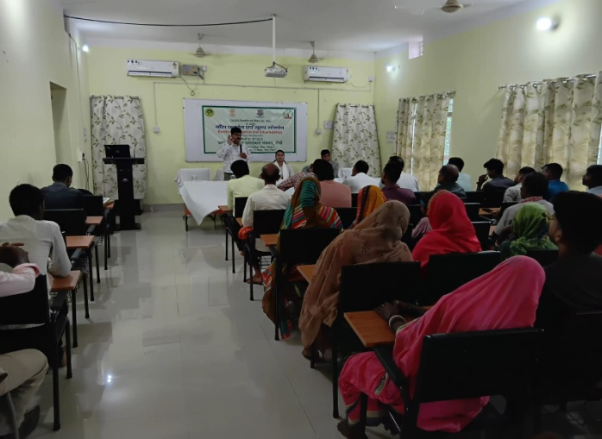
Training program under VVK, Jadua, Hajipur, Bihar
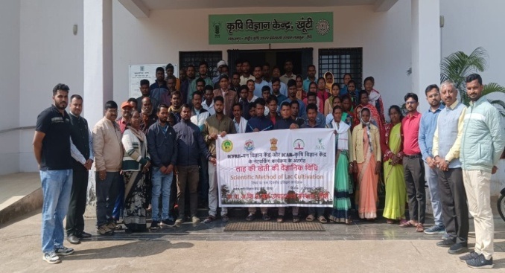 | 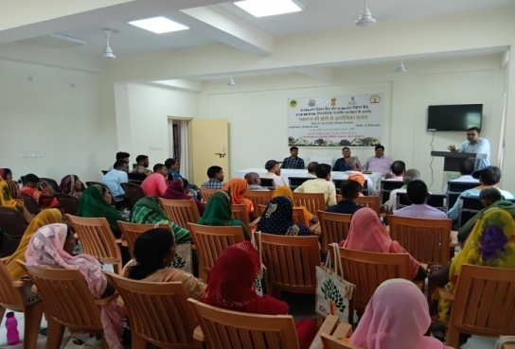
Training program under VVK-KVK networking at KVK, Khunti | Training program under VVK-KVK networking at KVK, Mandu, Ramgarh

Demo Village
The Demo Village concept was initiated by the Indian Council of Forestry Research and Education (ICFRE) to effectively disseminate forestry-based technologies developed by ICFRE and its institutes to end users, particularly farming communities.
At ICFRE-Institute of Forest Productivity (IFP), Ranchi, the Demo Village serves as a model for sustainable rural development focusing on environmentally responsible practices. Implemented in active collaboration with forestry extension programs, it aims to build resilient village communities by enhancing their skills, awareness, and capacity to address challenges related to natural resource depletion, climate change, and environmental sustainability.
The initiative showcases practicalsolutions for agroforestry, soil and water conservation, livelihood enhancement and climate-resilient farming practicesempowering local communities as active stakeholders in sustainable development.
Name of Demo-village | District & State | Date of Establishment | Location | GPS Coordinates
Hapamuni, Gumla | Gumla, Ranchi | 2008-2012 | Hapamuni, Gumla
Kutam, Torpa | Khunti, Jharkhand | September 2021-March 2025 | Kutam, Torpa | 22°56´38.7846” N  85°12´29.0988” E
Jidu, Angara, Ranchi | Ranchi | April 2025 | Jidu, Angara, Ranchi on Ranchi Purulia Road | 23° 22' 5.1492"N & 85° 36' 22.2732"E

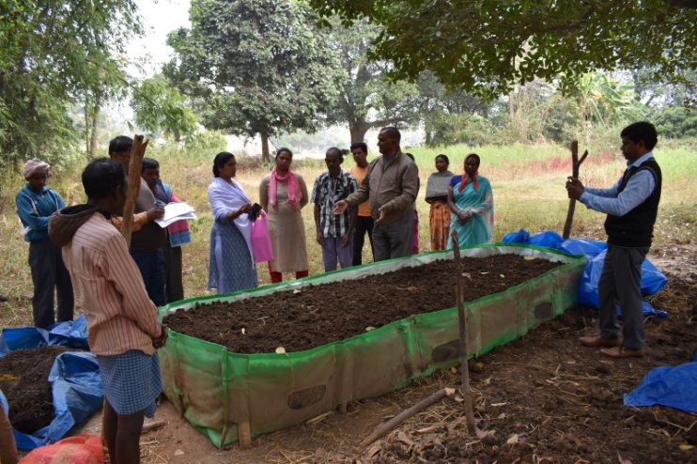  Training on Vermi composting techniques | 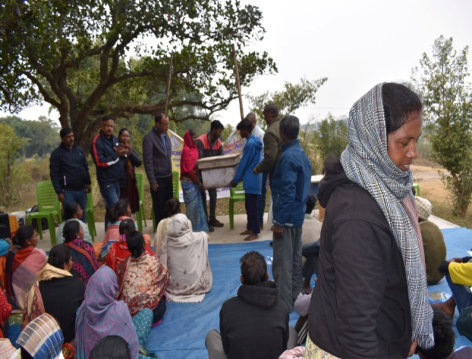  Training on Honey production using honey bees
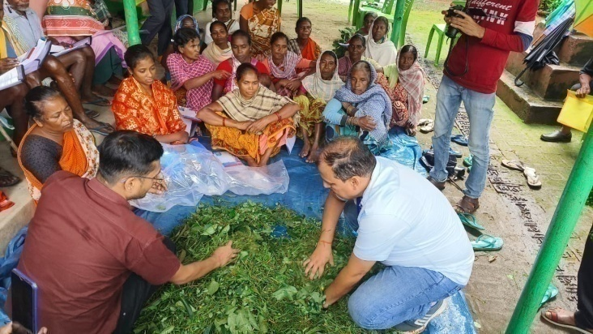  Training on Silage production | 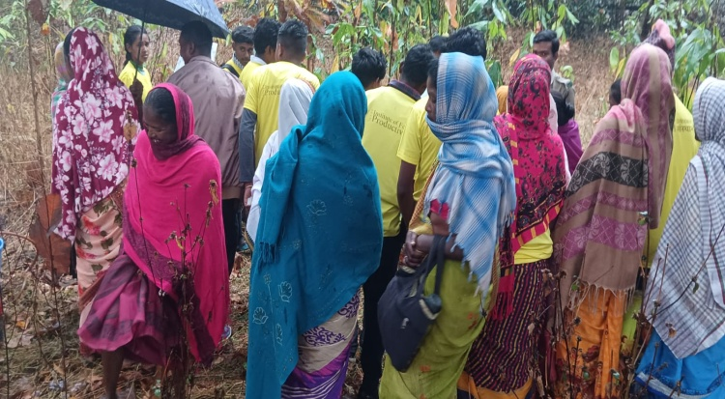  Training on Lac Cultivation on Flemingia
Demo Village Kutam, Khunti
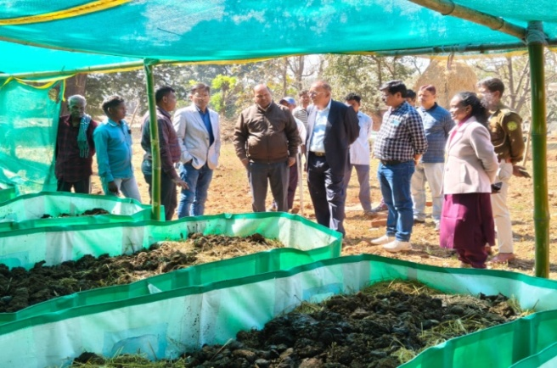  Establishment of Vermi composting units in village | 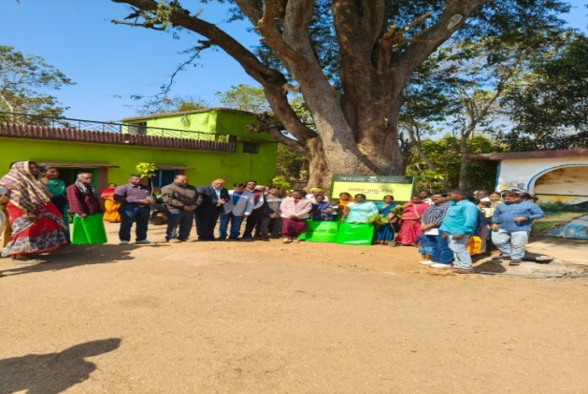  Training on Promotion of Soil Health
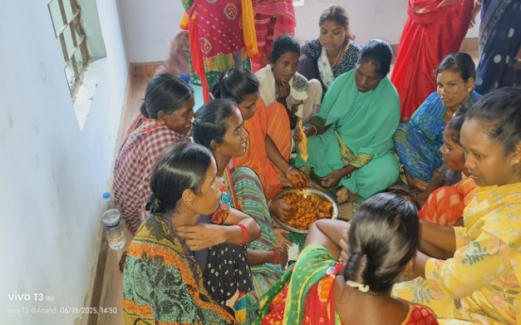  Training on value addition of wild edible fruit | 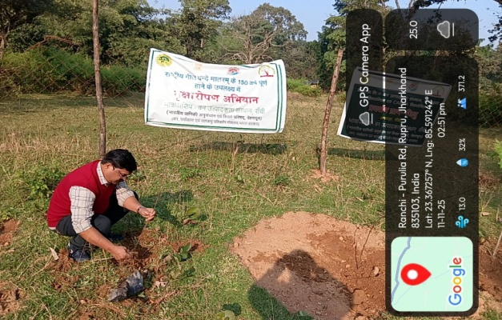  Plantation Program at Demo Plot
Demo Village Jidu, Angara, Ranchi

